Name: _________________________________ Period: ________ Date: _________

Tall Tale Assignment
English 5 Mr. Gathman

Directions: Write a tall tale following the format that was discussed in class.

This needs to be between 1 and 2 pages double-spaced.

Fill out the graphic organizer and turn it in with your tall tale. If the graphic organizer is not turned in, your writing process score will be affected.

USE YOUR NOTES, RUBRIC, AND GRAPHIC ORGANIZER! If you don’t follow proper format or forget an essential element of tall tales your grade will not forget that you forgot.

Things to Remember:
- Make sure any handwriting is easily legible
- Turn this sheet in with the assignment
- Grammar and spelling are vital while writing in prose
- All assignments must be school appropriate
  - Inappropriate assignments earn 0s

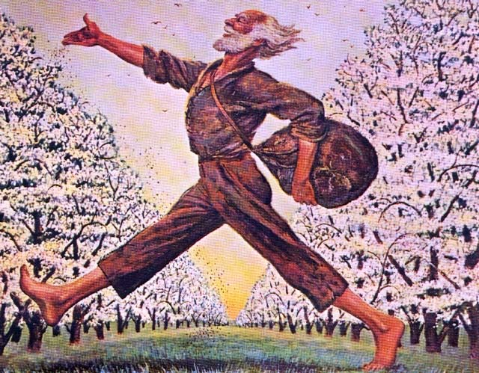

Tall Tale Rubric Name: ________________________
CATEGORY | 5 | 4 | 3 | 2 / 1
Writing Process  (All Scores) | Student devotes a lot of time and effort to the writing process (prewriting, drafting, reviewing, and editing). Works hard to make the story wonderful. | Student devotes sufficient time and effort to the writing process (prewriting, drafting, reviewing, and editing). Works and gets the job done. | Student devotes some time and effort to the writing process but was not very thorough. Does enough to get by. | Student devotes little time and effort to the writing process. Doesn't seem to care.  Assignment is turned in late.
Title  (Elements of Fiction) | Title is creative, sparks interest and is related to the piece. | Title is appealing and its relation to piece is apparent. | Title is related to the piece. | Title is present, but does not appear to be related to the piece.
Setting  (Elements of Fiction) | Many vivid, descriptive words are used to tell when and where the story took place. | Some vivid, descriptive words are used to tell the audience when and where the story took place. | The reader can figure out when and where the story took place, but the author didn't supply much detail. | The reader has trouble figuring out when and where the story took place.
Descriptive Writing  (Elements of Fiction) | The actions and events of the tall tale are easily visible to the reader because of advanced use of descriptive words. | The actions and events of the tall tale are relatively visible to the reader because of proficient use of descriptive words. | The actions and events of the tall tale are visible to the reader because of basic use of descriptive words. | The actions and events of the tall tale are not easy to visualize.
First Person POV  (Tall Tale Elements) | The writer successfully tells the story in first person. | The story is mostly written in first person. | The writer weaves back and forth telling the story sometimes in first person. | The writer has not been clear in identifying who is telling the story.
Main Character  (Tall Tale Elements) | Reason behind character’s name is explained, character’s appearance is covered, the character is described as a youth, and the character is exactly the kind of hero needed at the time and place of the setting. | Reason behind character’s name is explained, character’s appearance is covered, and the character is exactly the kind of hero needed at the time and place of the setting. | Character’s appearance is covered; the character is exactly the kind of hero needed at the time and place of the setting. | The main character is not the hero that he/she should be for the time and place.
Conflict/Solution  (Tall Tale Elements) | Unrealistic problem arises and is solved in an ‘impossible’ manner. | Unrealistic problem arises and is solved in a ‘quasi-impossible’ manner. | Unrealistic problem arises and is solved. | A problem arises that is solved.
Exaggeration  (Tall Tale Elements) | The writer uses numerous examples of exaggeration | The writer uses a few examples of exaggeration. | The writer uses one or two examples of exaggeration. | The writer does not use any exaggeration.
Capitalization & Punctuation  (Conventions) | Writer makes no errors in capitalization or punctuation, so the paper is exceptionally easy to read. | Writer makes 1 or 2 errors in capitalization or punctuation, but the paper is still easy to read. | Writer makes a few errors in capitalization and/or punctuation that catch the reader's attention and interrupt the flow. | Writer makes several errors in capitalization and/or punctuation that catch the reader's attention and greatly interrupt the flow.
Grammar & Spelling  (Conventions) | Writer makes no errors in grammar or spelling that distract the reader from the content. | Writer makes 1-2 errors in grammar or spelling that distract the reader from the content. | Writer makes 3-4 errors in grammar or spelling that distract the reader from the content. | Writer makes more than 4 errors in grammar or spelling that distract the reader from the content.
Requirements (Conventions) | All of the written requirements (# of pages, # of graphics, type of graphics, etc.) were met. | Almost all (about 90%) the written requirements were met. | Most (about 75%) of the written requirements were met, but several were not. | Many requirements were not met.
Neatness  (Conventions) | The final draft of the story is readable, clean, neat and attractive. It is free of erasures and crossed-out words. It looks like the author took great pride in it. | The final draft of the story is readable, neat and attractive. It may have one or two erasures, but they are not distracting. It looks like the author took some pride in it. | The final draft of the story is readable and some of the pages are attractive. It looks like parts of it might have been done in a hurry. | The final draft is not neat or attractive. It looks like the student just wanted to get it done and didn't care what it looked like.

Elements of Fiction Score: _______ Tall Tale Elements Score: _______ Conventions Score: _______

Overall Score: ________

