Senior Capstone Project
Social Satire Assignment
Mr. Gathman English 7/8

Description: Satire is the art of bringing attention to a problem, fault, or issue by blending criticism with humor. Satire is used to show foolishness or corruption in people, organizations, or governments.

Objective: Creatively provide an understanding of the ills of the world while writing in a style similar to works read this semester.

Requirements: 2.5-3 page short story satirizing a topic related to the modern world

Characteristics: Use of irony, sarcasm, and humor. Relation to a current event or societal problem.
- Verbal irony – saying one thing, but meaning another
- Situational irony – events are not what was expected
- Dramatic irony – reader has information the characters need, but don’t have
- Sarcasm – Bitter remark utilizing humor, but often serious/painful

Possible Topics:

- Fixation with social media
- American education system
- Gun control
- Global warming
- Social/racial prejudice
- Population control
- Identity theft
- Brexit
- Health care
- Government control
- Homelessness
- Etc.

Preparing to Write:
- Check current events
- Choose what you care about
- Dig deeper into the topic
- Know your audience (Gathman)
- Choose a goal (audience reaction)
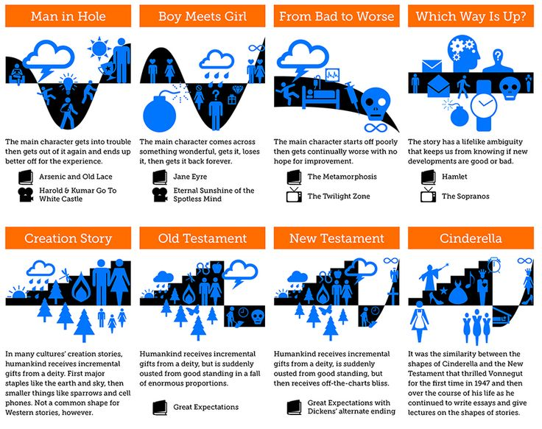
Writing your Satire:
- Pick a story path
- Incorporate humor
- Use satire
- Exaggerate to make a point
- Make sure your characters matter

