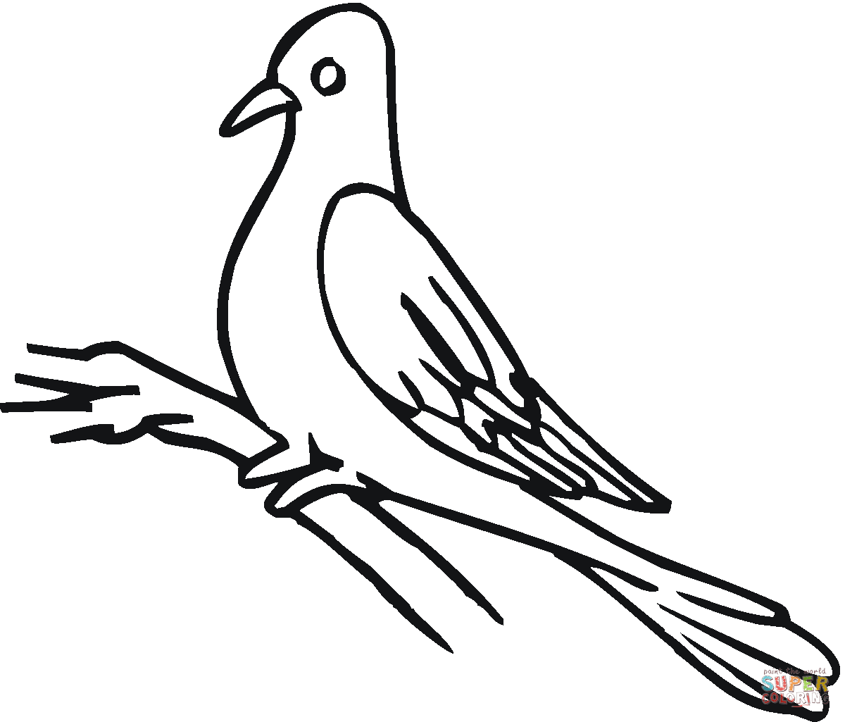

\* Poo-tee-weet.

\*