Illustrated Words – The Old Man and the Sea
English 4 – Mr. Gathman

Directions:
Create an art piece using words from and/or related to The Old Man and the Sea. The words chosen can create the image, OR images can make up a word of focus (per the differing examples). These words can be anything you choose including direct quotes. Careful, detailed planning will be vital to success.

Requirements:
- Creative art piece that explores symbolism, characterization, and setting with the novel
- 2+ paragraph explanation of the piece, its intended symbolism, and the work’s importance
- Participation in the gallery walk held during the second half of the final day

Objectives:
- Portray a character’s personality, traits, and mindset
- Effectively relate an important moment or symbol from the novel
- Provide a quality written explanation of your artwork relating all vital information
- Cite direct quotes properly (at least 3 quotes are needed either in the artwork or the explanation)
- Chose and discuss many different pieces during the in-class gallery walk

Materials:
You can use any of the art materials in the classroom. You can also use supplies from home.

Suggested Timeline:
Day 1 – Receive assignment directions, brainstorm, begin rough draft(s)
Day 2 – create rough draft(s) and begin creating final draft
Day 3 – complete final draft during 1st 30 minutes of class, gallery walk during 2nd half of class
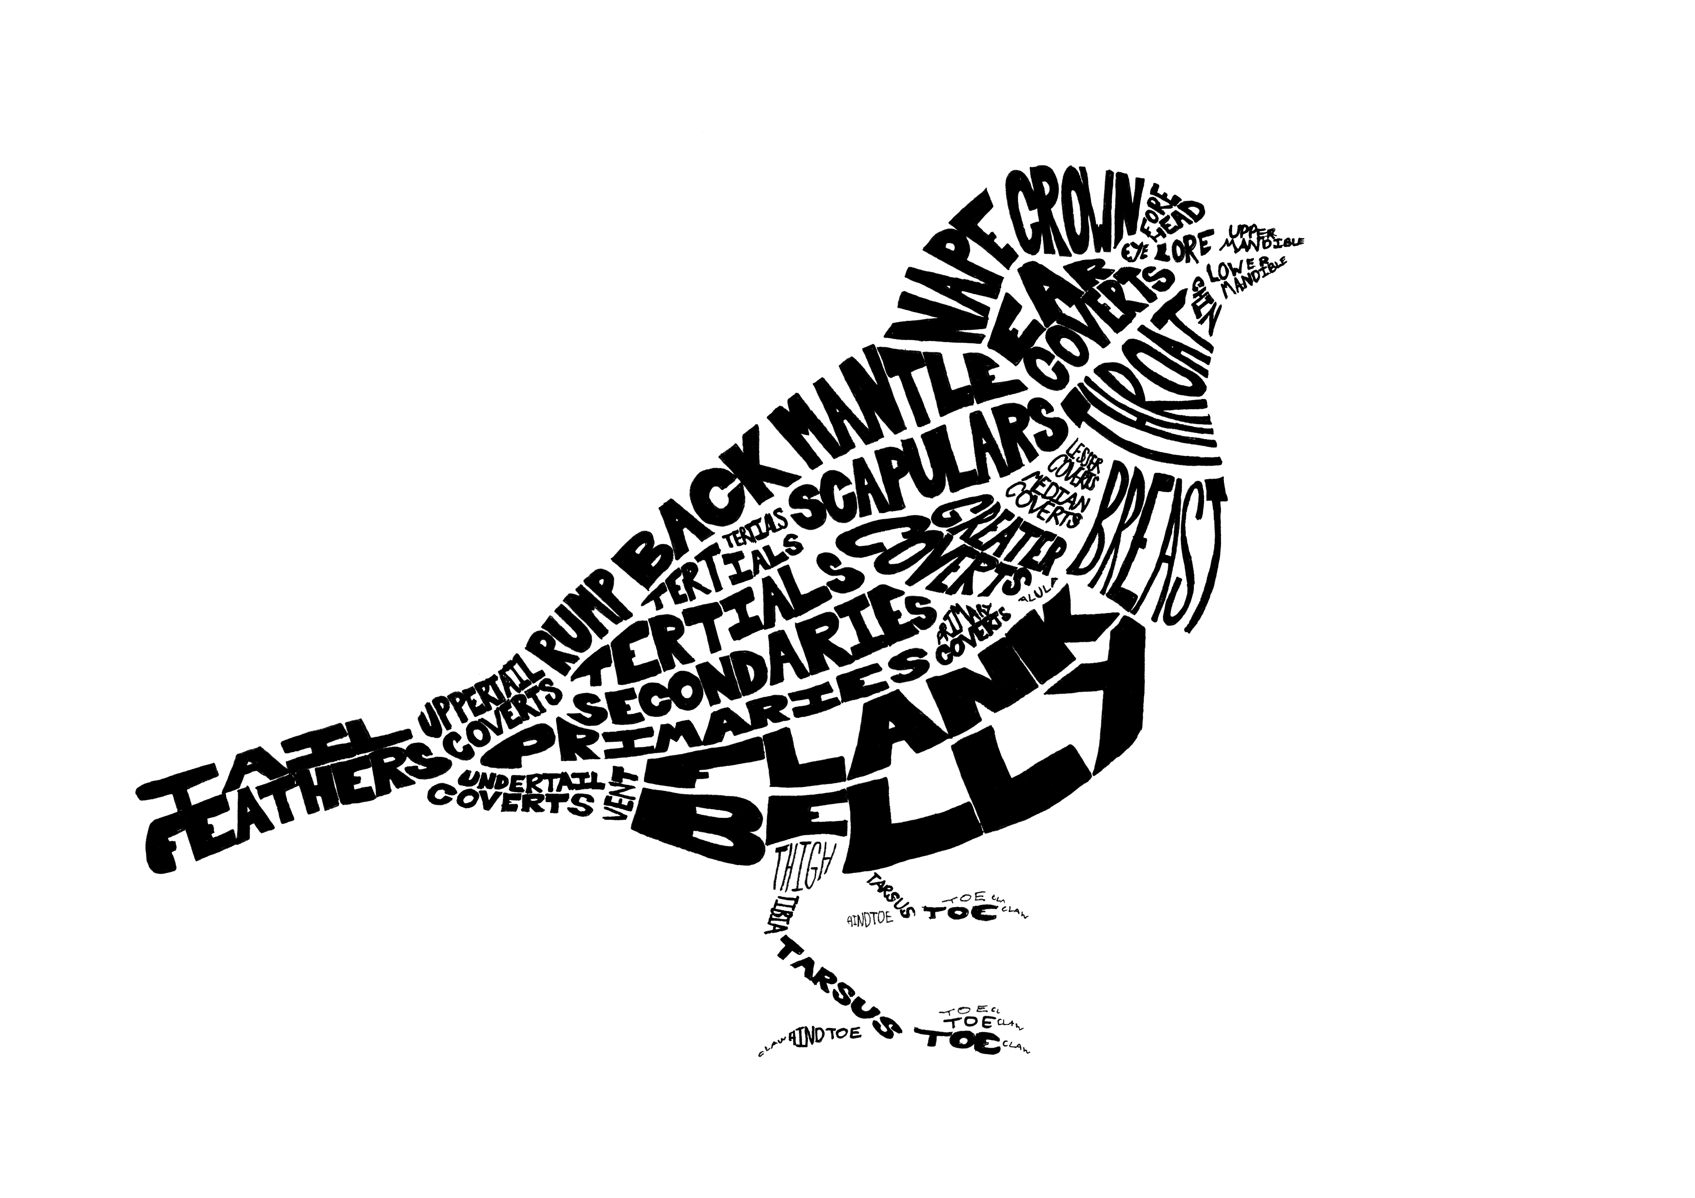
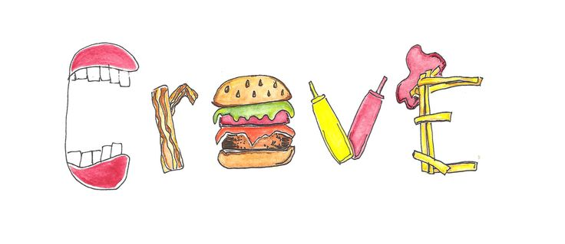
Examples

Crave – Images making up a word of focus

Bird Anatomy – Words creating the image

