Name: _________________________________________ Date: __________ Block: _______ Score: ______/4

Lord of the Flies Worst Case Scenario Project
English 7 • Mr. Gathman

You need to create 5 Worst Case Scenario Posters related to Lord of the Flies.

These scenarios should only talk about things that came up in the novel or would have been useful for the boys (ex: how to build a fire, fortifying a stronghold, etc.).

You will need a quote and page number(s) on each poster showing the need for the information.

Make sure that you include both the steps and the picture in order to fully explain how to avoid these situations. Have fun with this – you are probably not a survivalist, so create the steps to the best of your ability.
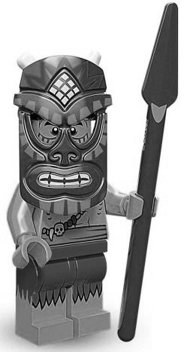
You will be presenting 3 of these to the class – this will be a Speaking and Listening score.

Things to remember:
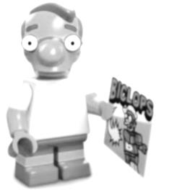
- Each Poster needs to be 8.5” by 11”
- Make sure any handwriting is easily legible
  - Typing is allowed (not necessary)
- Pictures must be hand drawn
- Make sure your name is on every card
- All assignments must be school appropriate
  - Inappropriate assignments earn 0s

CATEGORY | 4 | 3 | 2 | 1
Process | Student worked the entirety of the given work time and received both stamps | Student worked for almost the entire time during the given work time and received both stamps | Student worked for most of the time for the given work time and received both stamps | Student was distracted during the work time or did not receive both stamps
Lord of the Flies | Cards show the importance of the survival tactic to the boys on the island. Information is creative and relevant to the story. | Cards show the boys’ need for the survival tactic. Information is creative and relevant to the story. | Cards show the boys’ need for the survival tactic. Information is relevant to the story. | Cards do not deal with an important problem for the boys or are not creative/relevant.
Accuracy –  Quotes & Passages | All supportive facts and statistics are reported accurately. | Almost all supportive facts and statistics are reported accurately. | Most supportive facts and statistics are reported accurately. | Most supportive facts and statistics were inaccurately reported.
Execution of Illustrations | Illustrations are neat and visually pleasing throughout the entire work. | Illustrations are neat and visually pleasing throughout a majority of the work. | Illustrations are neat throughout a majority of the work. | Illustrations need more details and attention to visual appearance.
The Illustrations’ Support of the Plot | The illustrations help present the plot throughout all areas in the work. | The illustrations help present the plot in a majority of areas throughout the work. | The illustrations help present the plot in most areas throughout the work. | The illustrations help present the plot in only a minority of areas throughout the work.
Text | The font and legibility of the text do not interfere with or disrupt communication of ideas to the reader in any area of the work. | The font and legibility of the text do not interfere with or disrupt communication of ideas to the reader in almost all areas of the work. | The font and legibility of the text do not interfere with or disrupt communication of ideas to the reader in most areas of the work. | The font and legibility of the text interfere with or disrupt the communication of ideas to the reader.
Word Choice | Uses language that is specific and precise. Displays language that is appropriate for topic and audience. Avoids clichés and jargon. | Language is usually specific and precise, but occasionally seems forced or contrived. | Language is occasionally specific and precise, but often seems forced or contrived. | Language is rarely specific and often makes use of clichés and/or jargon.
Conventions | Writer makes no errors in grammar or spelling that distract the reader from the content. | Writer makes 1-2 errors in grammar or spelling that distract the reader from the content. | Writer makes 3-4 errors in grammar or spelling that distract the reader from the content. | Writer makes more than 4 errors in grammar or spelling that distract the reader from the content.

