Poet Focus: Sara Teasdale

Sara Teasdale (August 8, 1884 – January 29, 1933) was an American lyric poet. Teasdale’s work had always been characterized by its simplicity and clarity, her use of classical forms, and her passionate and romantic subject matter.

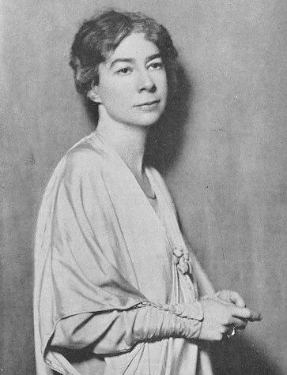

“There Will Come Soft Rains”

(War Time)

There will come soft rains and the smell of the ground,
And swallows circling with their shimmering sound;

And frogs in the pools singing at night,
And wild plum trees in tremulous white,

Robins will wear their feathery fire
Whistling their whims on a low fence-wire;

And not one will know of the war, not one
Will care at last when it is done.

Not one would mind, neither bird nor tree
If mankind perished utterly;

And Spring herself, when she woke at dawn,
Would scarcely know that we were gone.

“Faults”

They came to tell your faults to me,
They named them over one by one;
I laughed aloud when they were done,
I knew them all so well before, —
Oh, they were blind, too blind to see
Your faults had made me love you more.

“Barter”

Life has loveliness to sell,
All beautiful and splendid things,
Blue waves whitened on a cliff,
Soaring fire that sways and sings,
And children’s faces looking up
Holding wonder in a cup.

Life has loveliness to sell,
Music like a curve of gold,
Scent of pine trees in the rain,
Eyes that love you, arms that hold,
And for your spirit’s still delight,
Holy thoughts that star the night.

Spend all you have for loveliness,
Buy it and never count the cost;
For one white singing hour of peace
Count many a year of strife well lost,
And for a breath of ecstasy
Give all you have been, or could be.

“What Do I Care?”

What do I care, in the dreams and the languor of spring,
That my songs do not show me at all?
For they are a fragrance, and I am a flint and a fire,
I am an answer, they are only a call.

But what do I care, for love will be over so soon,
Let my heart have its say and my mind stand idly by,
For my mind is proud and strong enough to be silent,
It is my heart that makes my songs, not I.

All works in public domain.
Poet Focus: Siegfried Sassoon

Siegfried Loraine Sassoon, (8 September 1886 – 1 September 1967) was an English poet, writer, and soldier. Decorated for bravery on the Western Front, he became one of the leading poets of the First World War. He was a recipient of the Most Excellent Order of the British Empire as well as the Military Cross.

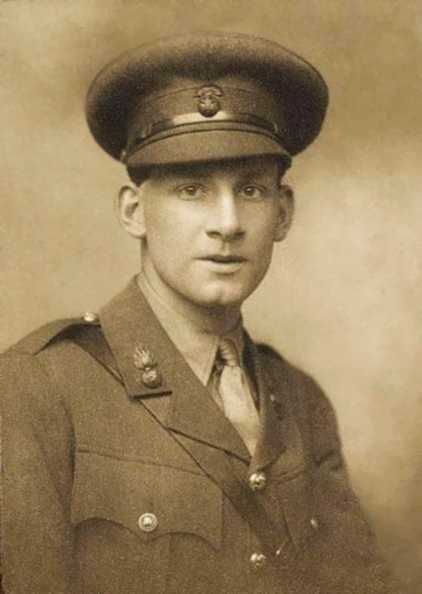

“Suicide in the Trenches”

I knew a simple soldier boy
Who grinned at life in empty joy,
Slept soundly through the lonesome dark,
And whistled early with the lark.

In winter trenches, cowed and glum,
With crumps and lice and lack of rum,
He put a bullet through his brain.
No one spoke of him again.

You smug-faced crowds with kindling eye
Who cheer when soldier lads march by,
Sneak home and pray you'll never know
The hell where youth and laughter go.

All works in public domain.

“To a Very Wise Man”

I

FIRES in the dark you build; tall quivering flames
In the huge midnight forest of the unknown.
Your soul is full of cities with dead names,
And blind-faced, earth-bound gods of bronze and stone
Whose priests and kings and lust-begotten lords 5
Watch the procession of their thundering hosts,
Or guard relentless fanes with flickering swords
And wizardry of ghosts.

II

In a strange house I woke; heard overhead
Hastily-thudding feet and a muffled scream... 10
(Is death like that?) ... I quaked uncomforted,
Striving to frame to-morrow in a dream
Of woods and sliding pools and cloudless day.
(You know how bees come into a twilight room
From dazzling afternoon, then sail away 15
Out of the curtained gloom.)

III

You understand my thoughts; though, when you think,
You’re out beyond the boundaries of my brain.
I’m but a bird at dawn that cries ‘chink, chink’—
A garden-bird that warbles in the rain. 20
And you’re the flying-man, the speck that steers
A careful course far down the verge of day,
Half-way across the world. Above the years
You soar ... Is death so bad? ... I wish you’d say.

“The Hawthorn Tree”

NOT much to me is yonder lane
Where I go every day;
But when there’s been a shower of rain
And hedge-birds whistle gay,
I know my lad that’s out in France
With fearsome things to see
Would give his eyes for just one glance
At our white hawthorn tree.
. . . .
Not much to me is yonder lane
Where he so longs to tread:
But when there’s been a shower of rain
I think I’ll never weep again
Until I’ve heard he’s dead.

Poet Focus: John Ashbery

John Lawrence Ashbery (born July 28, 1927) is an American poet. He has published more than twenty volumes of poetry and won nearly every major American award for poetry, including a Pulitzer Prize in 1976 for his collection Self-Portrait in a Convex Mirror.

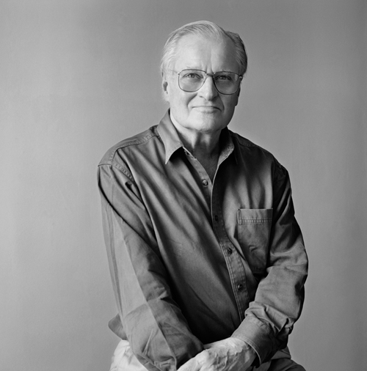

“Flowering Death”

Ahead, starting from the far north , it wanders.
Its radish-strong gasoline fumes have probably been
Locked into your sinuses while you were away.
You will have to deliver it.
The flowers exist on the edge of breath, loose,
Having been laid there.
One gives pause to the other,
Or there will be a symmetry about their movements
Through which each is also an individual.

It is their collective blankness, however,
That betrays a notion of a thing not to be destroyed.
In this, how many facts we have fallen through
And still the old facade glimmers there,
A mirage, but permanent. We must first trick the idea
Into being, then dismantle it,
Scattering the pieces on the wind,
So that the old joy, modest as cake, as wine as of friendship
Will stay with us at the last, backed by the night
Whose ruse gave it our final meaning.

From Poetry, July 1979.

“They Dream Only of America”

They dream only of America
To be lost among the thirteen million pillars of grass:
"This honey is delicious
Though it burns the throat."

And hiding from darkness in barns
They can be grownups now
And the murderer's ashtray is more easily --
The lake a lilac cube.

He holds a key in his right hand.
"Please," he asked willingly.
He is thirty years old.
That was before

We could drive hundreds of miles
At night through dandelions.
When his headache grew worse we
Stopped at a wire filling station.

Now he cared only about signs.
Was the cigar a sign?
And what about the key?
He went slowly into the bedroom.

"I would not have broken my leg if I had not fallen
Against the living room table. What is it to be back
Beside the bed? There is nothing to do
For our liberation, except wait in the horror of it.

And I am lost without you."

From The Partisan Review, Summer 1959.

“A Poem of Unrest”

Men duly understand the river of life,
misconstruing it, as it widens and its cities grow
dark and denser, always farther away.

And of course that remote denseness suits
us, as lambs and clover might have
if things had been built to order differently.

But since I don't understand myself, only segments
of myself that misunderstand each other, there's no
reason for you to want to, no way you could

even if we both wanted it. Do those towers even exist?
We must look at it that way, along those lines
so the thought can erect itself, like plywood battlements.

From Can You Hear, Bird by John Ashbery, 1995.
Poet Focus: William Butler Yeats

William Butler Yeats (13 June 1865 – 28 January 1939) was an Irish poet and one of the foremost figures of 20th-century literature. In 1923, he was awarded the Nobel Prize in Literature.

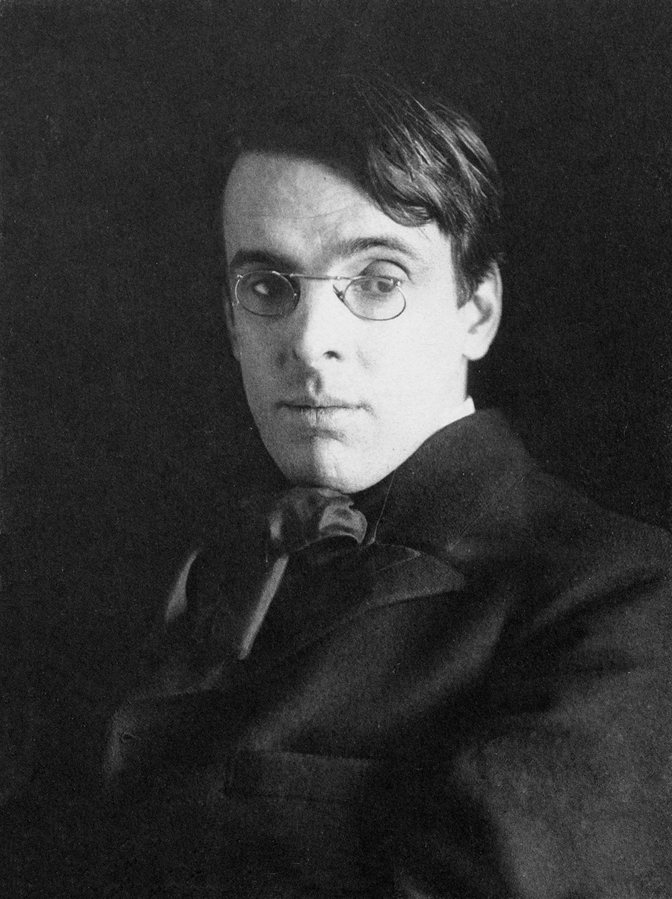

“The Second Coming”

Turning and turning in the widening gyre
The falcon cannot hear the falconer;
Things fall apart; the centre cannot hold;
Mere anarchy is loosed upon the world,
The blood-dimmed tide is loosed, and everywhere
The ceremony of innocence is drowned;
The best lack all conviction, while the worst
Are full of passionate intensity.

Surely some revelation is at hand;
Surely the Second Coming is at hand.
The Second Coming! Hardly are those words out
When a vast image out of Spiritus Mundi
Troubles my sight: a waste of desert sand;
A shape with lion body and the head of a man,
A gaze blank and pitiless as the sun,
Is moving its slow thighs, while all about it
Wind shadows of the indignant desert birds.

The darkness drops again but now I know
That twenty centuries of stony sleep
Were vexed to nightmare by a rocking cradle,
And what rough beast, its hour come round at last,
Slouches towards Bethlehem to be born?

Work in the public domain.
Poet Focus: Warsan Shire

Warsan Shire (‬‎‎born August 1, 1988) is a London–based- Somali writer, poet, editor and teacher. She has received the Brunel University's African Poetry Prize, chosen from a shortlist of six candidates out of a total 655 entries. Shire's poetry featured prominently in Beyoncé's 2016 feature length film Lemonade.‬‬

“what they did yesterday afternoon”

they set my aunts house on fire
i cried the way women on tv do
folding at the middle
like a five pound note.
i called the boy who used to love me
tried to ‘okay’ my voice
i said hello
he said warsan, what’s wrong, what’s happened?

i’ve been praying,
and these are what my prayers look like;
dear god
i come from two countries
one is thirsty
the other is on fire
both need water.

later that night
i held an atlas in my lap
ran my fingers across the whole world
and whispered
where does it hurt?

it answered
everywhere
everywhere
everywhere.
“Home” by Warsan Shire

no one leaves home unless
home is the mouth of a shark
you only run for the border
when you see the whole city running as well

your neighbors running faster than you
breath bloody in their throats
the boy you went to school with
who kissed you dizzy behind the old tin factory
is holding a gun bigger than his body
you only leave home
when home won’t let you stay.

no one leaves home unless home chases you
fire under feet
hot blood in your belly
it’s not something you ever thought of doing
until the blade burnt threats into
your neck
and even then you carried the anthem under
your breath
only tearing up your passport in an airport toilet
sobbing as each mouthful of paper
made it clear that you wouldn’t be going back.

you have to understand,
that no one puts their children in a boat
unless the water is safer than the land
no one burns their palms
under trains
beneath carriages
no one spends days and nights in the stomach of a truck
feeding on newspaper unless the miles travelled
means something more than journey.
no one crawls under fences
no one wants to be beaten
pitied

no one chooses refugee camps
or strip searches where your
body is left aching
or prison,
because prison is safer
than a city of fire
and one prison guard
in the night
is better than a truckload
of men who look like your father
no one could take it
no one could stomach it
no one skin would be tough enough
the
go home blacks
refugees
dirty immigrants
asylum seekers
sucking our country dry
niggers with their hands out
they smell strange
savage
messed up their country and now they want
to mess ours up
how do the words
the dirty looks
roll off your backs
maybe because the blow is softer
than a limb torn off

or the words are more tender
than fourteen men between
your legs
or the insults are easier
to swallow
than rubble
than bone
than your child body
in pieces.
i want to go home,
but home is the mouth of a shark
home is the barrel of the gun
and no one would leave home
unless home chased you to the shore
unless home told you
to quicken your legs
leave your clothes behind
crawl through the desert
wade through the oceans
drown
save
be hunger
beg
forget pride
your survival is more important

no one leaves home until home is a sweaty voice in your ear
saying-
leave,
run away from me now
i dont know what i’ve become
but i know that anywhere
is safer than here﻿

© Warsan Shire, @warsan_shire
Poet Focus: Mário de Andrade

Mário de Andrade (October 9, 1893 – February 25, 1945) was a Brazilian poet, novelist, musicologist, art historian, and photographer. One of the founders of Brazilian modernism, he virtually created modern Brazilian poetry with the publication of his Paulicéia Desvairada (Hallucinated City) in 1922.

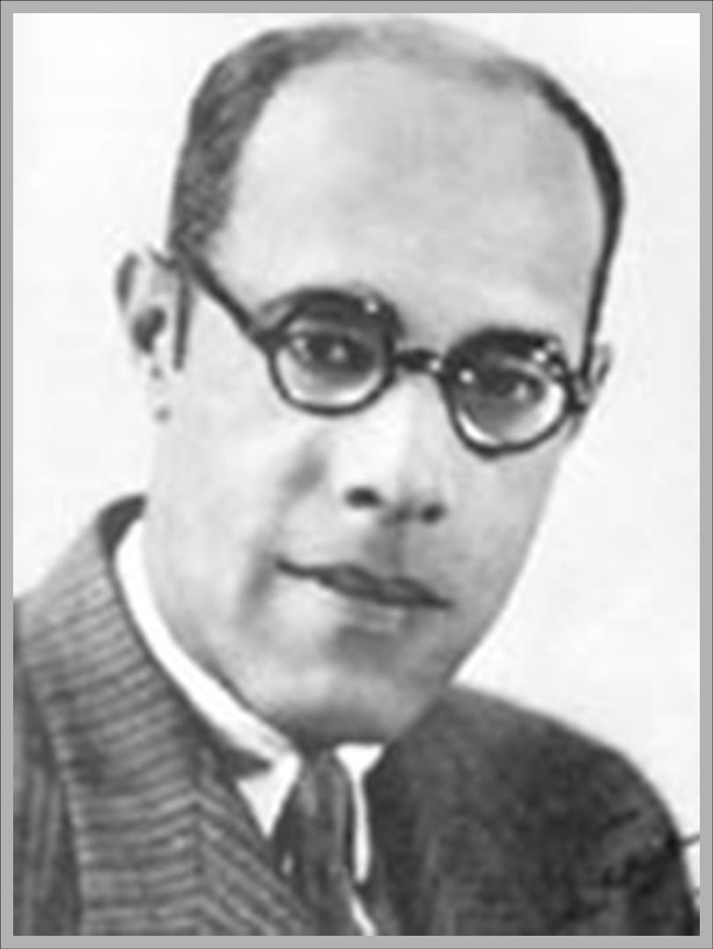

“Aspiration”

The sweetness of poverty like this…
To lose everything your, even the egoism of being,
So poor that you can only belong to the crowd…
I gave away everything mine, I spent all my being,
And I possess only what in me is common to all..
The sweetness of poverty like this…

I am not lonely any more, I am dissolved among equal men!

I have walked. Long my way
The emphatic mark of my steps
Remained on ground wet with morning dew.

Then the Sun ascended, heat vibrated in the air
In golden particles of light and warm breath.

The ground burned and hardened.
The mark of my feet is now invisible…

But the Earth remains, the tenderly dumb Earth,
And growing, grieving, dying in Earth,
The always equal men remain…

And I feel larger, equalizing myself to the equal men!
“Impromptu for a Dead Youth”

Dead, gently he rests upon the blossoms in the coffin.
There are such moments when living
This life of self-interest and savage conflict,
One tires of gathering desires and cares.
Then for an instant we abandon the murmur of the body,
The wandering mind leaves off its musings,
And tenderly comes oblivion.
Who then delights in the roses to his side?
The lovely prospect crossed by motorcar?
The thought that glorifies? . . .
The body is like a veil cast over furniture,
A gesture that we have forgotten quite.
Dead, gently he forgets upon the blossoms in the coffin.

It does not seem he sleeps, nor say I he dreams happy, he is dead.
In one of life’s moments the spirit forgot itself and stopped.
Suddenly he was astonished by the confusion of weeping about his head,
He felt perhaps a great disappointment
To have let life slip, he so strong, he so young,
He was piqued and stirred no more.
And now no more will stir.

Go away! go away, dead boy!
Oh, go away, I do not know you now!
Do not come back by night to gird my destiny ‘round!
With the light of your presence and your desire to think!
Do not return to offer me your valiant hope,
Nor ask me the shape of the Earth for your dreams!

The universe moans beneath the blazing flash of this catastrophe,
Anxieties criss-cross frightened in mid-air,
And this peace of mine is intolerable and giant-huge!
My tears fall upon you and you are like a shattered sun!
What freedom in your oblivion!
What staunch independence in your death!
Oh, go away, I do not know you now!

All works in the public domain.

