New Names for Equality 7-2521 & Liberty 5-3000
PROMETHEUS was the Titan god of forethought and crafty counsel who was entrusted with the task of moulding mankind out of clay. His attempts to better the lives of his creation brought him into direct conflict with Zeus. Firstly he tricked the gods out of the best portion of the sacrificial feast, acquiring the meat for the feasting of man. Then, when Zeus withheld fire, he stole it from heaven and delivered it to mortal kind hidden inside a fennel-stalk. As punishment for these rebellious acts, Zeus ordered the creation of Pandora (the first woman) as a means to deliver misfortune into the house of man, or as a way to cheat mankind of the company of the good spirits. Prometheus meanwhile, was arrested and bound to a stake on Mount Kaukasos where an eagle was set to feed upon his ever-regenerating liver (or, some say, heart). Generations later the great hero Herakles came along and released the old Titan from his torture.  Prometheus was loosely identified in cult and myth with the fire-god Hephaistos and the giant Tityos. | 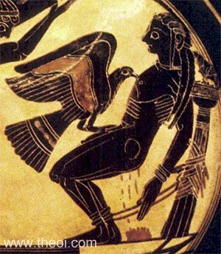
GAIA (or Gaea) was the Protogenos (primeval divinity) of earth, one of the primal elements who first emerged at the dawn of creation, along with air, sea and sky. She was the great mother of all : the heavenly gods were descended from her union with Ouranos (the sky), the sea-gods from her union with Pontos (the sea), the Gigantes from her mating with Tartaros (the hell-pit) and mortal creatures were sprung or born from her earthy flesh.  In myth Gaia appears as the prime opponent of the heavenly gods. First she rebelled against her husband Ouranos (Sky) who had imprisoned her sons in her womb. Then later, when her son Kronos defied her by imprisoning these same sons, she assisted Zeus in his overthrow of the Titan. Finally she came into conflict with Zeus, angered with him for the binding of her Titan-sons in the pit of Tartaros. In her opposition she first produced the tribe of Gigantes and later the monster Typhoeus to dethrone him, but both failed in both attempts.  Gaia was depicted as a buxom, matronly woman, half risen from the earth (as in the image right) in Greek vase painting. She was portrayed as inseperable from her native element. In mosaic art, Gaia appears as a full-figured, reclining woman, often clothed in green, and sometimes accompanied by grain spirits--the Karpoi. | 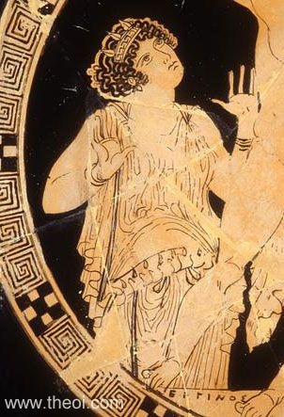

Information from http://www.theoi.com/

